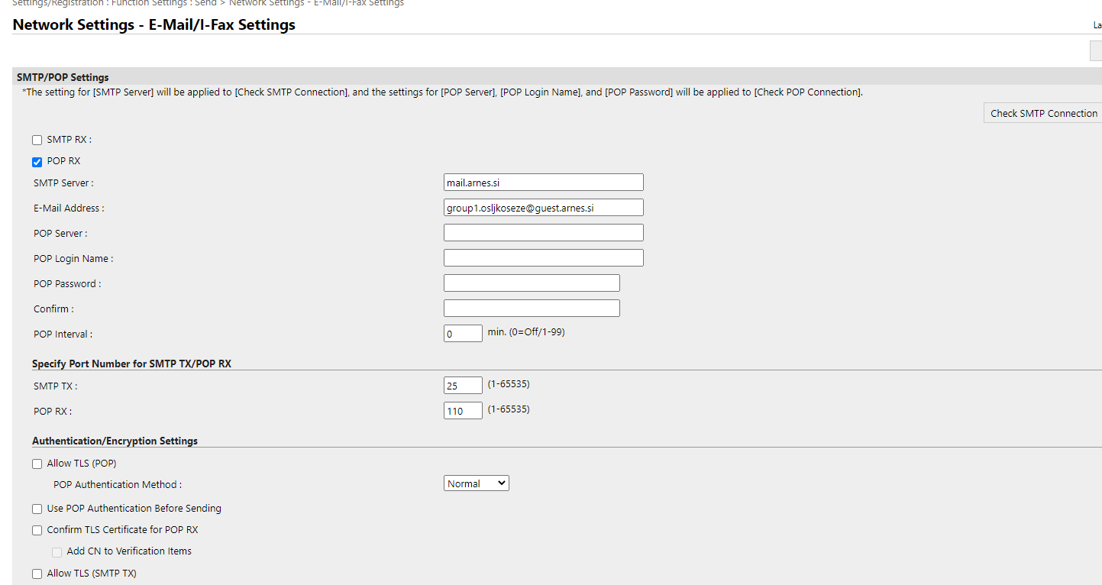

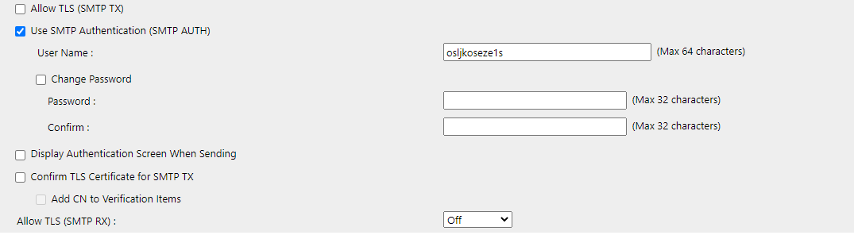

MAC naslo: 60-12-8b-d2-bc-22